40 Organisational Scanning Questions

These questions look at your business and its susceptibility to changes in market conditions and other events. In short it tests the rigour of your business.

Answer all of the questions honestly and if you prefer, get your key Management team involved in answering the questions with you. It creates an excellent forum for an open and honest review of your business and will illustrate areas of weakness that will need addressing. Summarise your findings and put an action plan together to resolve the challenges.

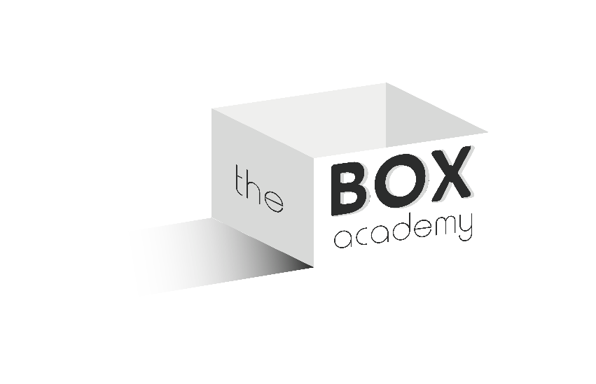
If you would prefer one of our Experts to analyse your responses and give you their thoughts just a go to our Ask the Expert feature and look for the Book a Consultation option and submit your request for and Expert to review your findings. This review and report can be done for a small additional payment.
- Strategic Focus
- What major domestic and world events are having a negative effect on your organisation? What are some specific examples of the impact?
- What is likely to be the response of the organisation to these events? What could be done to increase the organisation’s flexibility?
- Who would be adversely affected by organisational adjustment to these events?
- In what specific way is the organisation most likely to change as a result of any shifts in strategic focus?

- Business Outlook
- What would be the likely effects on your organisation of a downturn in business? How could the negative impact of such a downturn be limited?
- To what extent is the business affected by currency fluctuations, inflation, interest rates etc.? What is the impact on the business of these fluctuations?
- What is the current financial position of the business? What strategies are in place to improve this position?
- How aware are the people within the business of the financial position and your strategies?
- In what specific way is the organisation most vulnerable to impact from business and financial conditions?

- Technology
- What currently available equipment would significantly upgrade your processes?
- What technical knowledge or training would significantly upgrade the skills of the people responsible for these processes?
- What impact would new or improved technology have on the co-ordination of work between the different teams within the business?
- What other significant consequences would there be from new or improved technology? What systems or policies, if any, would be affected?
- In what specific way is the organisation vulnerable to impact from technology?

- Environmental/ Consumer Protection
- What are the environmental/ consumer issues that are affecting the organisation? Name specific business areas that are affected?
- What are the trends in these areas that will likely affect the business in the near future?
- How sensitive are your people to these issues? Where do you stand on observance/ compliance with these requirements?
- What change/ improvement can the organisation make now to prepare for the future?
- In what specific way is the organisation most vulnerable to impact from environmental/ consumer concerns?

- Customers/ Markets
- Who are your major customers?
- What are their expectations and how well are they being delivered?
- Is the market for your goods/ services declining, expanding or relatively flat? What are the likely implications of this market situation for you?
- What specifically can you do to increase the growth potential of the business? What can you do to become more competitive?
- In what specific ways are you vulnerable to market changes?

- Suppliers
- Who are your major suppliers? How good is your working relationship with them?
- How are they aware of the processes used by your business?
- Have any of your suppliers helped you address production or service problems? Would they be willing to do so in the future?
- What more could you do in this area that would benefit the business now?
- Is it likely that your external suppliers will change in the near future? What are your criteria for selecting new suppliers? In what ways can your suppliers provide you with a competitive advantage?
- In what specific ways are you most vulnerable to impact from suppliers?

- Competition
- What are the key features of your competition’s products or services that differentiate theirs from yours?
- What operational advantages do they have over your business – e.g. more automation, better product design, better customer service.
- What could you do to overcome these advantages? In what specific area could improvements be introduced that could lead to competitive advantage?
- In what specific ways is the business vulnerable to impact from competition?

- People
- How satisfied are your people with the organisation? What are the major things that cause dissatisfaction?
- Can the business retain top talent? Why/ why not?
- Do all employees get fair advancement opportunities?
- In what ways has the business accommodated the needs of a diverse workforce (e.g. benefit packages, flexi time, childcare issues?
- How much training/ development time is provided for employees? Is it focused on the right skills or areas of knowledge to keep or make the organisation competitive?
- What additional contribution can you make in this area?
- In what specific ways is the organisation most vulnerable to impact from demographic factors?

